CASE STUDY
Pod Plug SEO Case Study: Lovable SSR Migration + Indexing Recovery
Pokémon vending machine locator • Location-based search • Technical SEO / SSR / indexing recovery
Website: podplug.com
From JavaScript crawlability issues to a search-friendly SSR setup, broader index coverage and visible post-migration recovery. The project connected technical SEO, migration protection, indexing, local search architecture, content planning and measurement into one recovery system.
118  PAGES INDEXED  after technical work | 1.81K  GOOGLE CLICKS  latest 28 days | 157K  IMPRESSIONS  latest 28 days | 8.5  AVG. POSITION  improved vs 8.7

What I Owned
- SSR / crawlability fixes
- URL, metadata & schema cleanup
- Location SEO architecture
- Internal crawl paths & indexing
- Content / keyword roadmap
- Google Search Console + Microsoft Clarity monitoring
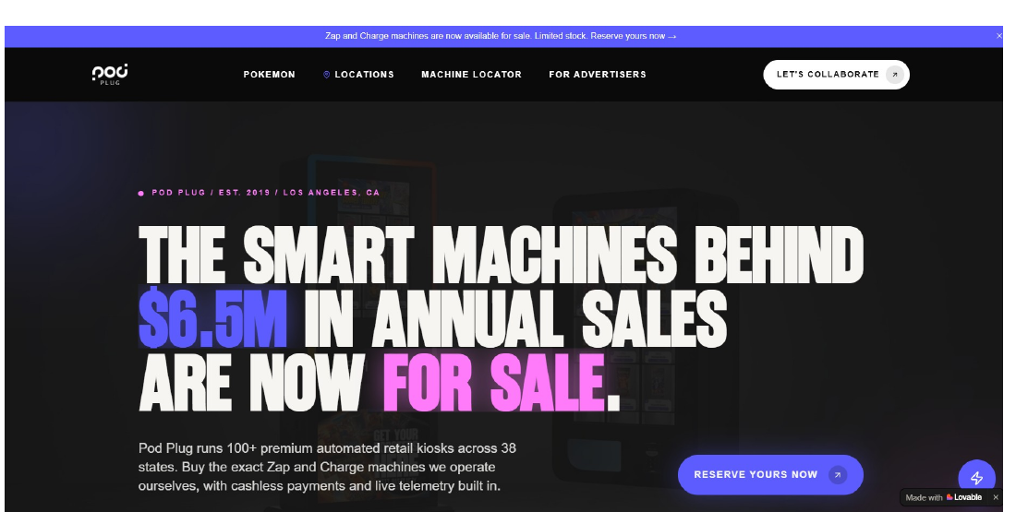
Pod Plug website after the Lovable / SSR migration work | Open proof
Suggested image alt text: Pod Plug website after Lovable SSR migration and technical SEO improvements

The Problem: A Migration That Was Also a Search-Engine Architecture Problem
The migration was not just a design rebuild. Lovable / JavaScript pages created crawlability, indexing and location-page SEO risk. The fix was to make the new site easier for Google to discover, render, understand and re-index.

What I Changed
01 | SSR & crawlability  Moved critical content toward server-rendered / crawlable delivery and tested the staging environment.
02 | URL & metadata system  Cleaned URL structure, titles, metadata, canonicals and schema targets.
03 | Internal discovery  Strengthened crawl paths between core pages, location hubs, city pages and supporting content.
04 | Migration protection  Mapped old content to new URLs and documented redirect requirements to preserve equity.
05 | Local SEO architecture  Built state/city keyword mapping and a machine-location strategy for scalable local discovery.
Outcome: the new platform became structurally safer for search while Google re-crawled the rebuilt pages and organic visibility began stabilising.

Indexing Recovery
Index coverage expanded after the technical cleanup. The work focused on crawlability, URL hygiene, redirects, soft 404s, canonicals and location-page discovery, then tracked the recovery in Google Search Console.
118  INDEXED PAGES  GSC proof | 196  NOT INDEXED  8 reasons

What the Audit Uncovered
- 5 redirect URLs
- 6 alternate canonical URLs
- 20 crawled - not indexed URLs
- 5 discovered - not indexed URLs
- 18 soft 404s
- 10 true 404s
The goal was not to force every URL into the index. It was to separate valid redirects and canonical exclusions from real crawl and content problems, then fix the pages that mattered.
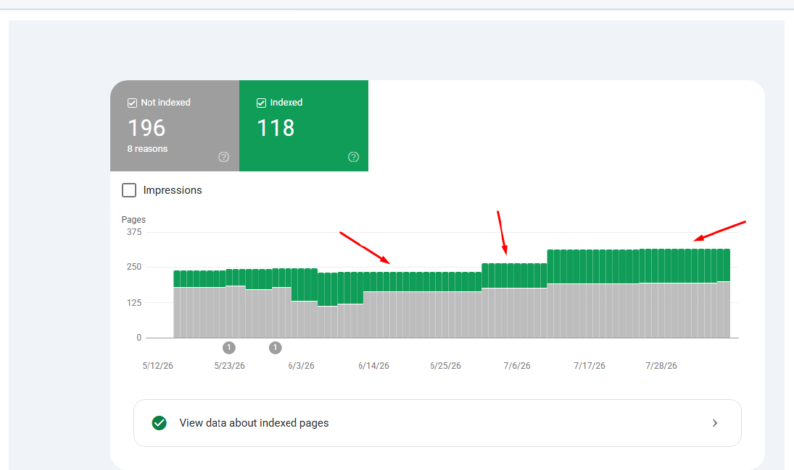
Google Search Console indexing proof - 118 indexed pages | Open proof
Suggested image alt text: Google Search Console index coverage showing 118 indexed Pod Plug pages after technical SEO work

Organic Search Recovery
Organic visibility held through the migration and started recovering. The migration created a temporary dip, but average position improved slightly while Google re-crawled the SSR pages and late-period visibility accelerated.
1.81K  CLICKS  latest 28 days | 157K  IMPRESSIONS  latest 28 days | 8.5  AVG. POSITION  vs 8.7 prior

1,059  GOOGLE VISITS  traffic source | 64  FORM SUBMISSIONS  conversion signal | 56  LOCATOR ACTIONS  high intent

Migration read: clicks moved from 1.89K to 1.81K (-4.2%), impressions from 186K to 157K (-15.6%), while average position improved from 8.7 to 8.5. Recovery was visible at the end of the period.

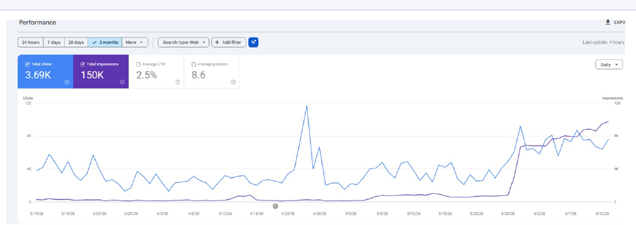
Search performance proof showing late-period visibility recovery | Open proof
Suggested image alt text: Pod Plug Google Search Console performance trend during SSR migration and SEO recovery
Detailed performance report: Open latest 28-day performance

Growth Architecture: Building the Next Search Layer
The work went beyond a migration fix. Keyword research, local landing-page architecture and content planning were designed around scalable demand for Pokémon vending, nightlife vending and machine-location searches.
40.5K  POKÉMON VENDING  monthly volume | 4.4K  NEAR ME  monthly volume | 550  FOR SALE  monthly volume

Keyword & Location Strategy
- Mapped seed keywords to dedicated landing pages.
- Expanded state-level targets for California, Texas, Georgia, Tennessee and more.
- Created city / location logic to support future machine-locator demand.
- Built content topics across informational, commercial and transactional intent.

Local SEO + Content Engine
State & city hubs: /locations/[state]/[city] style architecture
Machine-location intent: Near-me and city-based discovery paths
Support content: Restocks, Apple Pay, pricing and machine ownership
Local trust signals: Venue references, reviews and GBP / GMB planning
Authority growth: PR outreach and competitor guest-post prospecting
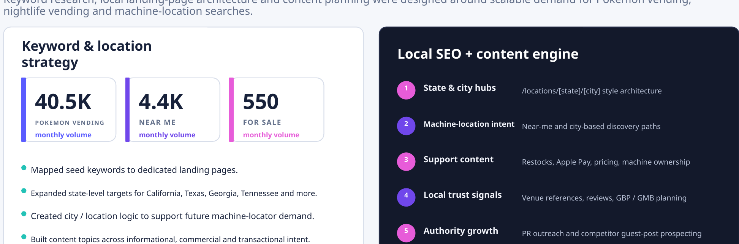
Growth architecture - keyword, location, local SEO and content engine
Suggested image alt text: Pod Plug SEO growth architecture with Pokémon vending keywords, location pages and local SEO content strategy
DELIVERABLE PROOF

Project Proof Library
The following links are direct project artifacts, proof sources or live implementation links from the Pod Plug work - not a generic service list.

Strategy, Migration & Technical SEO
Keyword Research: Refined keyword sheet - Open proof
Strategy: Competitive landscape & roadmap - Open proof
Build Spec: Location landing page build instructions - Open proof
Competitor: VapeTM blog insight - Open proof
On-page: Metadata & keywords - Open proof
Baseline: Current website stats - Open proof
Strategy: SEO recommendations - Open proof
Migration: Migration mapping sheet - Open proof
GSC: Google Search Console report - Open proof
Content: New blog topic sheet - Open proof
Content: Blog outline 1 - Open proof
Content: Blog outline 2 / Where to Find - Open proof

Local SEO, Content & Authority
Content: Pokémon vending business cost 2026 - Open proof
Technical: 404 pages sheet - Open proof
CRO: CTA recommendations - Open proof
Local SEO: Pod Plug Local SEO & GMB Master Plan - Open proof
Architecture: URL structure - Open proof
Strategy: Competitor Conquest gap analysis - Open proof
Outreach: PR outreach list - Open proof
Content: Blog titles + content tracker - Open proof
Compare: Pod Plug vs VapeTM content flow - Open proof
Outreach: Competitor guest-post opportunities - Open proof
Content: Do Pokémon vending machines take Apple Pay? - Open proof
Content: Truth about Pokémon vending restocks - Open proof

Indexing, Live Content & Reporting
Outreach: Outreach email template - Open proof
Indexing: Website indexing tracker - Open proof
Live Blog: How much does a Pokémon vending business cost? - Open proof
Live Blog: The truth about Pokémon vending machine restocks - Open proof
Proof: Indexing screenshot - Open proof
Proof: Performance screenshot - Open proof
Report: Latest 28-day performance - Open proof
Report: SEO master sheet - Open proof

The Result
I did not just "do SEO" on a Lovable site. I rebuilt the search foundation around the migration. The work connected technical SEO, SSR migration, indexing, local architecture, content strategy and measurement into one recovery system.
118  INDEXED PAGES  after technical work | 1.81K  GOOGLE CLICKS  latest 28 days | 157K  IMPRESSIONS  latest 28 days | 8.5  AVG. POSITION  improved vs 8.7

Client takeaway: Search visibility was stabilised while the site moved to a more scalable, search-friendly architecture.

Website Backend SEO Fields (Optional)
These fields are editorial recommendations for publishing this case study page on your website.
Suggested SEO Title: Pod Plug SEO Case Study | Lovable SSR Migration & Indexing Recovery
Suggested Meta Description: See how Pod Plug improved crawlability, indexing and location SEO through a Lovable SSR migration, reaching 118 indexed pages and 157K impressions.
Suggested URL Slug: /case-studies/pod-plug-seo-ssr-indexing-recovery/
Suggested Featured Image Alt Text: Pod Plug SEO case study for Lovable SSR migration and indexing recovery

